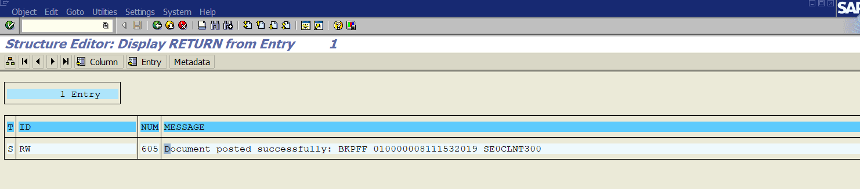

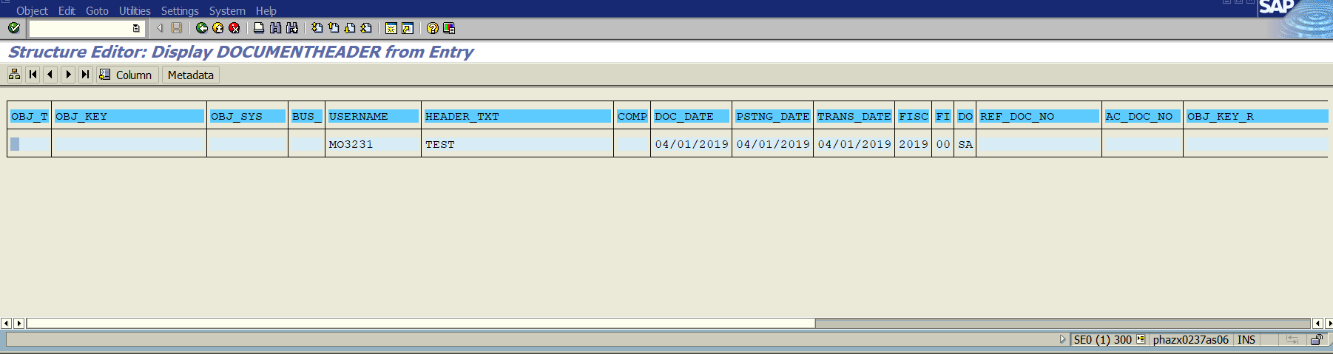

GL Line Item:

Line Item 1:

Item No: 0000000001

GL Account: 0010055000

Item Test: Test AP

Account Type: S

Document Type: SA

Company Code : 1153

Period: 00

Fiscal Year: 2019

Posting Date: 01.04.2019

Profit Centre: AD58437

Item No: 0000000002

GL Account: 0068500000

Item Test: Test AP

Account Type: S

Document Type: SA

Company Code : 1153

Period: 00

Fiscal Year: 2019

Posting Date: 01.04.2019

Cost Centre: DE58QP1000

Profit Centre: AD58437

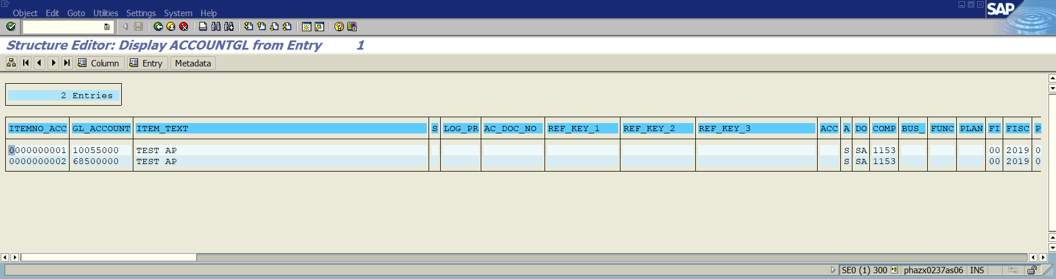

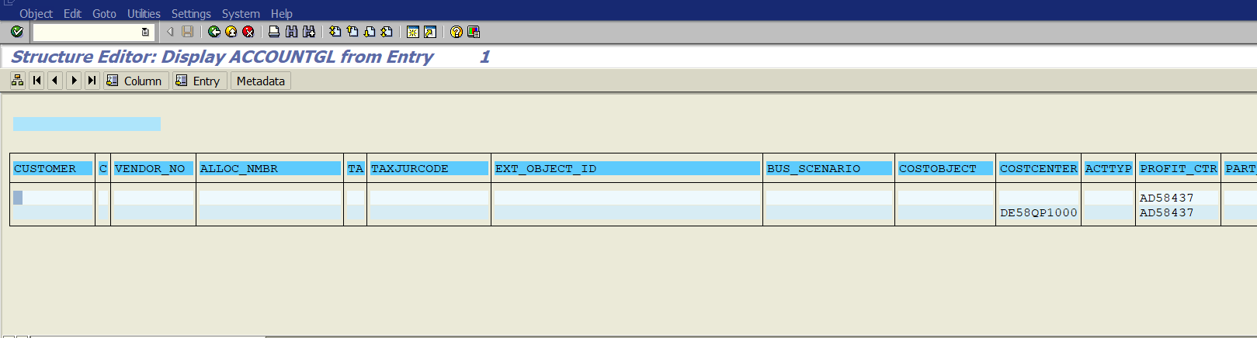

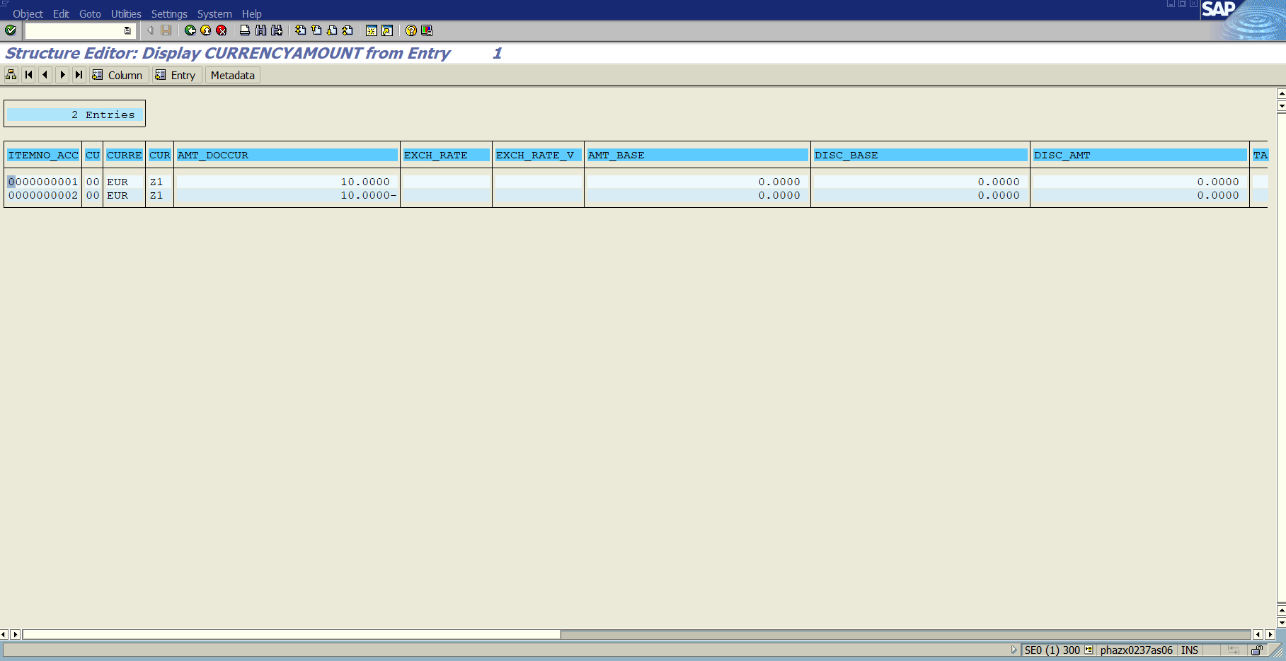

Item No: 0000000001

CU: 00

Currency: EUR

Amount in Document Currency: 10.0000

Item No: 0000000002

Currency Type: 00

Currency: EUR

Amount in Document Currency: -10.0000

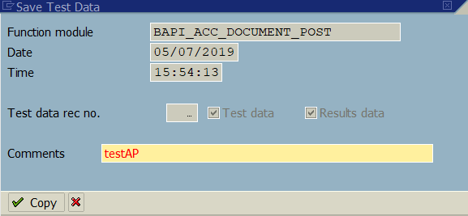

I also added an accounting principal in the header data, and it looks as if it posted to a specific ledger group based on the document number generated:

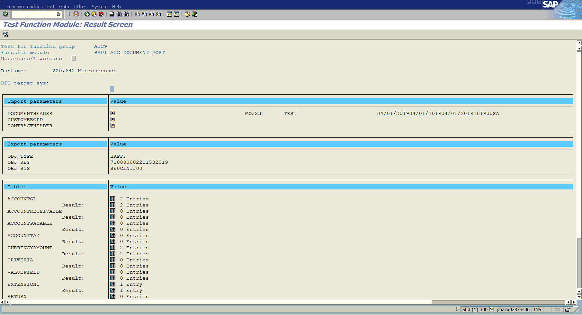

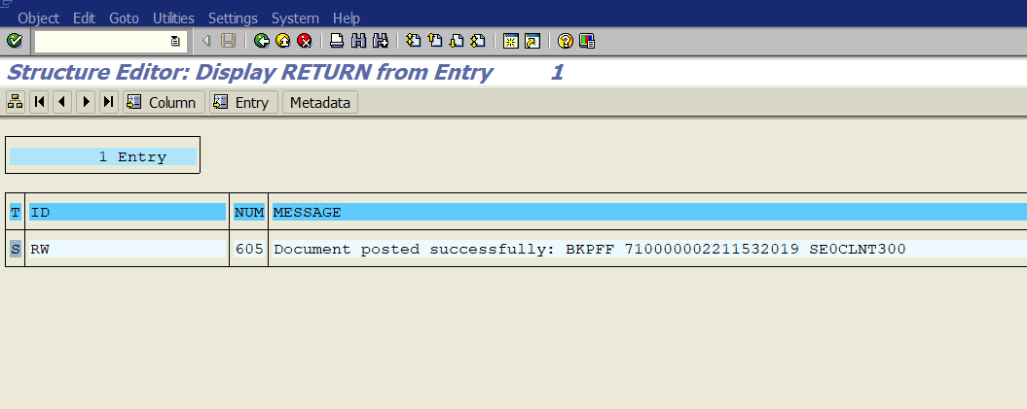

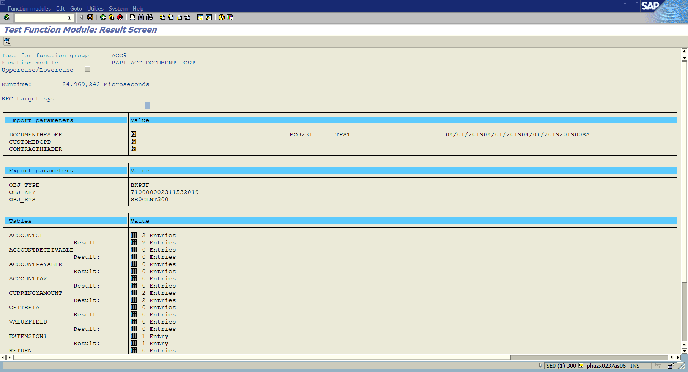

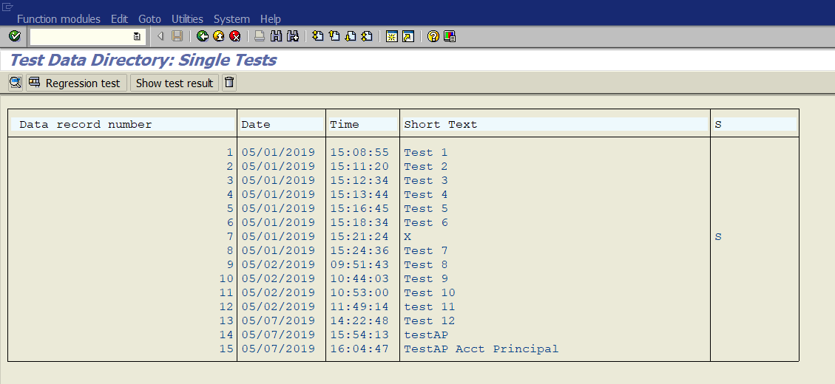

See data record numbers 14 and 15

Combined with badi comit,

Posted document:

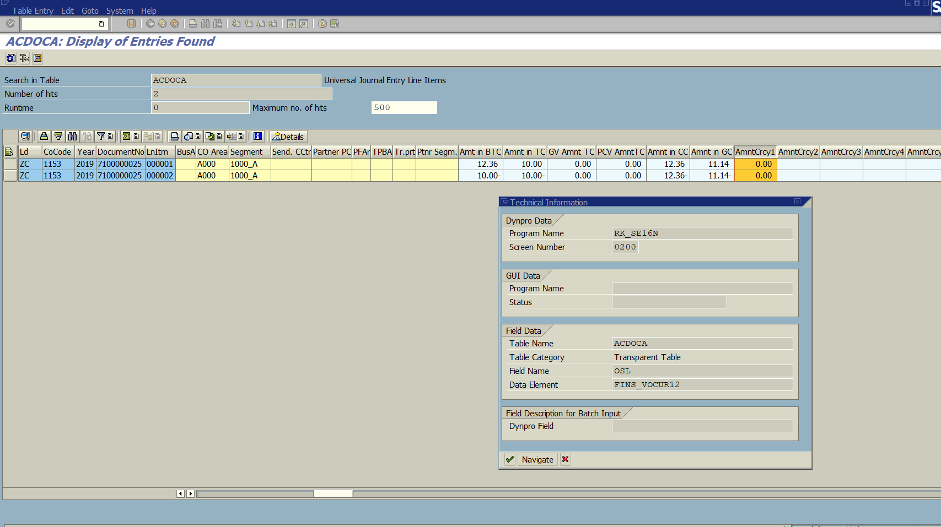

**My Question is now how do we populate AMNTCrcy1 in the table above via entries on the screen below? Also what are each of the currency fields on the screen below? I would like to know what is driving each of the currency fields below, such as what tables feed it values, and how it will then pass values on to the other fields?**

